NESciences, 2019, 4(1):55-64 doi: 10.28978/nesciences.522640
-SHORT COMMUNICATION-

Investigation of Sea Surface Temperature Affecting on the Maritime Trade between 1999 and 2012 in the Gulf of Iskenderun
Erdem Karpuz, Abdulla Sakalli

Iskenderun Technical University, Faculty of Marine Sciences and Technology,

İskenderun, Hatay

Abstract
The effect of sea surface temperature changes between 1999 and 2012 were investigated on the amount of agriculture, food and energy loads that are supplied/discharged by maritime trade. In the nonparametric correlation analysis, it was determined that the SST changes between 1999 and 2012 did not directly affect the amount of food, agricultural and energy supplied / discharged to the port operators in the Gulf of Iskenderun. There was little change in the amount of agricultural raw materials from Iskenderun Gulf and the amount of energy raw material increased. In addition, the amount of food raw materials increased between 1999-2002, 2005-2007 and 2009-2012 and it was observed that it decreased in other years.
Keywords:
Sea surface temperature, Iskenderun Gulf, maritime trade, correlation

Article history:
Received 18 September 2018, Accepted 24 November 2018, Available online 31 January 2019

Introduction
Nowadays, scientific research has shown that the transformation of greenhouse gases in the atmosphere into solid or liquid causes the warming of our planet's atmosphere and the climate change leading to climate system. Global warming and climate change has become a current and popular objest because they directly affect many sectors around the world. It is inevitable that climate change will affect the transportation sector and the sea trade.
Climate change was introduced by Swedish scientist Svante Arrhenius in the 19th century with the influence of industrialization as a concept. According to Arrhenius, changes in the constituents of the atmosphere can play a major role in the heat of our planet (Çalışkan et al., 2017).
According to the United Nations Economic Commission for Europe (UNECE) 2013 report, the most sector affected by climate change is stated as maritime transport. The report presents potential impacts of climate change on maritime trade as factors and impacts related to these factors. With the change of temperature averages, high energy consumption and damage to materials and transported loads occur.
In general terms, climate change can be described as "long-term and slow-growing changes, with climate conditions, large-scale (global) and significant local impacts whatever their cause" (Türkeş et al., 2000). Climate change is caused by higher levels of natural levels of greenhouse gases emitted to the atmosphere. These gases cause the temperature to rise on our planet near the surface of the atmosphere.The effect of the greenhouse is to reflect to the earth by the greenhouse gases in the atmosphere, in the form of long-wave heat rays, after short-wave rays from the sun hit the earth (Aksay et al., 2005).
Karaman and Gökalp (2010) stated that as a result of petroleum, coal and natural gas, the most important causes of global warming are greenhouse gases in the atmosphere. It is inevitable that the climate change has negative affect on Turkey. The changes in precipitation in latitudes where Turkey is located are related to the increase of water in the seas and the decrease of water absorption capacity of the soil. Because of these reasons, we will feel the negative situations such as the droughts, heatwaves, sudden floods, severe storms and lightning, erosion on our coasts and the reduction of groundwater (Kadıoğlu, 2001).
Sea transport is a process involving many activities such as shipbuilding, supply industry, aquaculture, ports, and other sub-structures, sea-environment, sea-tourism, aquaculture, sea-international relations, maritime legal norms (Metin, 2007). The average number of containers to be counted as the red blood cells of global maritime trade is around 8.5 times in one year (Surowiecki, 2000). Turan et al. (2016) analyzed the change in SST and its possible effects on biodiversity on the Mediterranean coast. They stated that SST has significantly increased in all seas since the last two decades.
The upper part of the sea and oceans, ranging from 10 μm to 20 meters, is called sea surface waters (Sakalli, 2017). In the study conducted by Sakalli, it was revealed that the SST data of the AVHRR 5.2 version satellite, which has a resolution of 4×4 km for the Mediterranean, covering the years of 1986-2015, increased by approximately 0.4 °C every ten years during the study period. Moreover, it is stated that the average SST will increase by 5.8 ° C in 2071-2100 period. Also, Gucel and Sakalli (2018) recently stated that the mean of SST in Iskenderun Bay increased by 1.5 °C.
This study was performed in order to determine whether the changes in the average of SST from 1999 to 2012 measured in Iskenderun Gulf had an effect on the increase or decrease in the amount of food, agriculture, and energy raw materials that were discharged/discharged to the port enterprises in the Iskenderun Gulf in the same years.
Materials and Methods
Eastern part of the Gulf of Iskenderun Mediterranean region, Adana from the west, the Gulf surrounded by the Antakya Mountains in the east. Çukurova plains in the north-northwest direction reach towards the gulf while the Amanos Mountains extend in the north-south direction in the east. The Ceyhan River is poured from the west into the gulf. Iskenderun district and its ports on the east coast, Yumurtalık Pier of Adana Province on the west coast.
The Gulf, which is closed to hard winds and has very salty water, has an important place in the Middle East and Mediterranean trade since the early ages. It is 80 km long between the Akıncı Burnu-Dörtyol District of the Akıncı Burnu (northeast-southwest) and 35 km wide between Yumurtalık-Iskenderun (west-east) (Koday, 1998). Iskenderun Gulf has an area of 65 km long, 35 km wide and 2275 km². The west of the bay has a height of about 200 meters (Avşar, 1999).
In this study, average SST of the Gulf of Iskenderun data from of 1999 to 2012 is obtained by Copernicus Marine Services. In the study, the types of freight coming and leaving the ports in the Gulf of Iskenderun are categorized and divided into groups: Load types; agriculture, energy, and food. The sample values of this study were taken from İskenderun Chamber of Commerce reports. The raw materials mentioned in Table 1 were monthly calculated as kilograms. The raw materials mentioned in Table 1 were monthly calculated as kilograms. Data on SST data and loads were analyzed by using SPSS 23.0 (Statistical Program for Social Sciences) package program. Load varieties and raw materials were given to the agriculture, energy and food categories coming to/from the ports of the Gulf of Iskenderun in 1999-2012 (Table 1).
Table 1. The agriculture, energy and food categories coming from / going to the ports of the Gulf of Iskenderun Authorities and the types of raw materials between 1999 and 2012 (DTO, 1999-2012)
Raw materials used in agriculture | Raw materials used in energy | Raw materials used in food
Ammonium nitrate  Ammonium Sulphate  Phosphate  Phosphate Fertilizer  Fertilizer  Composite Fertilizer  Urea  Seed  Potassium Sulfate  Sodium Phosphate | Liquid fuel  Gasoline  Fuel Oil  Kalyadi  Kerosene  Coal  LPG  Motorine  Jet Fuel  Oil  Crude oil  Petroleum Scent  Lignite | Sunflower  Barley  Corn  Rice  Soybean  Onion  Palm Oil  Corn oil  Flower oil  Peanut  Sunflower seeds  Soy oil  Sygau  Melas (Sugar Molasses)  Salt
The following formula was used to calculate the correlation coefficient value: Benesty at al. (2009)

(1)

In the formula;
r = correlation coefficient
X = Independent variable
Y = Dependent variable

Results
In this study, there are data to one hundred sixty eight for temperature, agricultural, energy and food loads released to the ports in Iskenderun Gulf.
In Table 2, the normality test was used in the SPSS package program to determine whether the average SST and incoming/outgoing loads (agriculture, energy, and food) were normally distributed. The results of the tests on the chart are Kolmogorov-Smirnov and Shapiro-Wilk. The results of the Kolmogorov-Smirnov test were taken into consideration as the number of data is more than 35. Critical values in the test;
Looking at the temperature variance, ρ = 0.000. Since ρ <0.05, it is said that the data are not normally distributed. The H₀ hypothesis is rejected. The data are not normally distributed. For agricultural variants, ρ = 0.059. Since ρ> 0.05, it is said that the data is normally distributed. The H₀ hypothesis can not be rejected. The data are normally distributed. Looking at the energy variance, ρ = 0.200. Since ρ> 0.05, it is said that the data is normally distributed. The H₀ hypothesis can not be rejected. The data are normally distributed. For the food variant, ρ = 0.000. Since ρ <0.05, it is said that the data are not normally distributed. The H₀ hypothesis is rejected. The data are not normally distributed (Büyüköztürk, 2018).
Table 2. Average SST, Agricultural, Energy, Normality test results of food variables.
Data | Kolmogorov-Smirnov |  |  | Shapiro-Wilk
 | Statistics | Data of Number | Importance Value | Statistics | Data of Number | Importance Value
Temperature | 0.131 | 168 | 0.000 | 0.904 | 168 | 0.000
Agriculture | 0.068 | 168 | 0.059 | 0.981 | 168 | 0.019
Energy | 0.047 | 168 | 0.200 | 0.992 | 168 | 0.502
Food | 0.134 | 168 | 0.000 | 0.874 | 168 | 0.000
Normality analysis shows that the data are not normally distributed and the data are not parametric. For energy and agricultural varieties, the data are normally distributed, and the data are parametric (Büyüköztürk, 2018).
The interpretation of the Kendall Tau-b test in Table 3 can be explained as follows: The Kendall Tau-b coefficient between temperature and agricultural variance was found to be -0.028, with a relationship between weak and negative. Kendall Tau-b coefficient between temperature and energy variance was found to be 0.060, and there is a relationship between weak and positive. The Kendall Tau-b coefficient between temperature and food variant was -0.047, and there is a relationship between weak and negative.

Table 3. Nonparametric Correlation between monthly mean Sea Surface Temperature data and Agriculture, Energy and Food Data Kendal Tau-b
 |  |  | Temperature | Agriculture | Energy | Food
Kendall's tau_b | Temperature | Correlation Coefficient | 1.000 | -0.028 | 0.060 | -0.047
 |  | Importance Value  (2-tailed) | . | 0.594 | 0.249 | 0.368
 |  | Number of Data (N) | 168 | 168 | 168 | 168
 | Agriculture | Correlation Coefficient | -0.028 | 1.000 | -0.008 | -0.053
 |  | Importance Value  (2-tailed) | 0.594 | . | 0.879 | 0.312
 |  | Number of Data (N) | 168 | 168 | 168 | 168
 | Energy | Correlation Coefficient | 0.060 | -0.008 | 1.000 | -0.099
 |  | Importance Value  (2-tailed) | 0.249 | 0.879 | . | 0.059
 |  | Number of Data (N) | 168 | 168 | 168 | 168
 | Food | Correlation Coefficient | -0.047 | -0.053 | -0.099 | 1.000
 |  | Importance Value  (2-tailed) | 0.368 | 0.312 | 0.059 | .
 |  | Number of Data (N) | 168 | 168 | 168 | 168

The interpretation of Spearman's test in Table 4 can be explained as follows: Spearman's rho rank correlation coefficient between temperature and agriculture variance was -0,048, and there is a relationship between weak and negative. Spearman's rho rank correlation coefficient between temperature and energy variance was found to be 0.092, and there is a relationship between weak and positive.
Spearman's rho rank correlation coefficient between temperature and food variance was -0.077, and there is a relationship between weak and negative (Gamgam & Altunkaynak, 2017).
Table 4. Nonparametric Correlation between monthly mean Sea Surface Temperature data and Agriculture, Energy and Food Data Spearman
 |  |  | Temperature | Agriculture | Energy | Food
Spearman's rho | Temperature | Correlation Coefficient | 1.000 | -0.048 | 0.092 | -0.077
 |  | Importance Value  (2-tailed) | . | 0.535 | 0.233 | 0.324
 |  | Number of Data (N) | 168 | 168 | 168 | 168
 | Agriculture | Correlation Coefficient | -0.048 | 1.000 | -0.011 | -0.078
 |  | Importance Value  (2-tailed) | 0.535 | . | 0.884 | 0.317
 |  | Number of Data (N) | 168 | 168 | 168 | 168
 | Energy | Correlation Coefficient | 0.092 | -0.011 | 1.000 | -0.142
 |  | Importance Value  (2-tailed) | 0.233 | 0.884 | . | 0.065
 |  | Number of Data (N) | 168 | 168 | 168 | 168
 | Food | Correlation Coefficient | -0.077 | -0.078 | -0.142 | 1.000
 |  | Importance Value  (2-tailed) | 0.324 | 0.317 | 0.065 | .
 |  | Number of Data (N) | 168 | 168 | 168 | 168

As a result of the nonparametric correlation analysis, it was determined that both negative and positive directional relations exist between agricultural, energy and food load amounts due to decreasing and increasing SST averages.
When the graph (Figure 1) is examined, it is seen that the amount of agricultural raw material that is coming to Iskenderun Gulf every year does not change much. The amount of agricultural raw materials is higher than average values between 1999-2001, 2004-2006 and 2009-2012 and under normal values in other years. The values of temperature average increase up to approximately 1.5 ⁰C degree between the years examined.

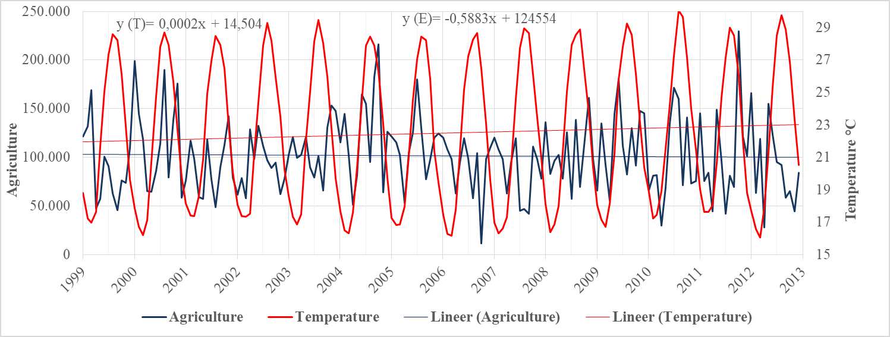
Figure 1. Annual average SST change in the Gulf of Iskenderun between 1999 and 2012 and the change of raw material loads used in agriculture.
When the graph (Figure 2) is examined, it is seen that the amount of energy raw material coming to the Iskenderun Gulf increases each year. Temperature averages increase to approximately 1.5 °C between years examined. When the maximum and minimum temperature values are examined by years, it is observed that the amount of energy raw material increases. In addition, there has been a positive increase in the amount of energy raw materials between these years.
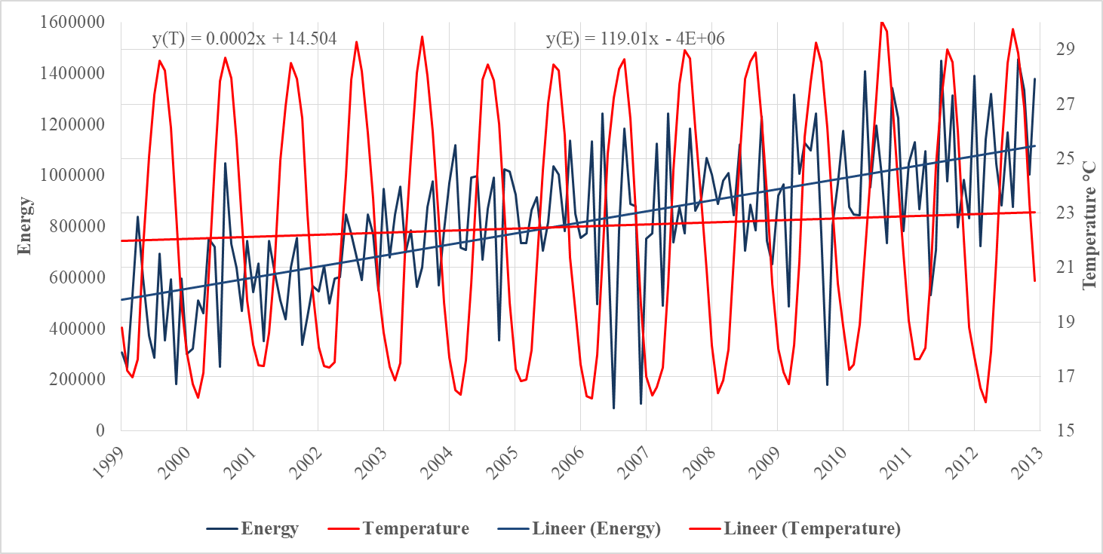
Figure 2. Annual average SST change in the Gulf of Iskenderun between 1999 and 2012 and the change of raw material loads used in energy.
When the graph (Figure 3) is examined, it is seen that the amount of agricultural raw material that has come to Iskenderun Bay every year does not change much. The amount of agricultural raw materials is above the normal values between 1999-2001, 2004-2006 and 2009-2012 and below the normal values in other years. Temperature averages increase to approximately 1.5 °C between years examined.
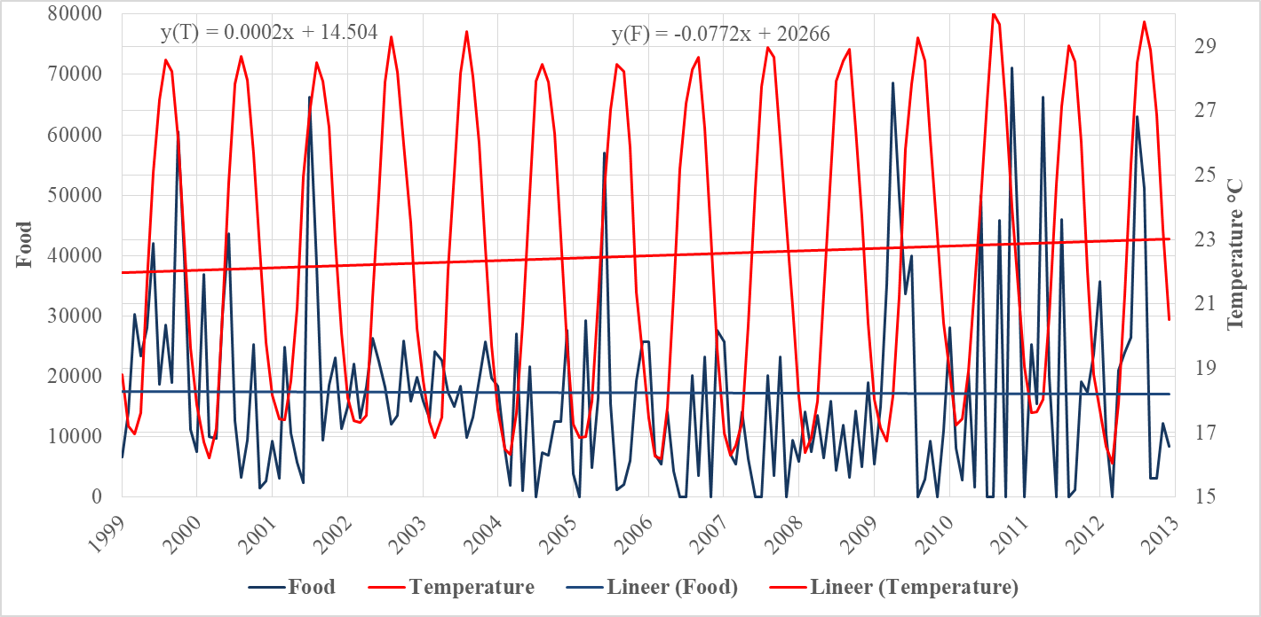
Figure 3. Annual average SST change in the Gulf of Iskenderun between 1999 and 2012 and the change of raw material loads used in food.
Discussion
In this study, it has been investigated that changing SST averages relating climate change can directly affect the trade of our categorized loads by SPSS. As a result of the analyzes performed in SPSS, there was no significant relationship between the variables, and it was analyzed that SST changes did not directly affect the increase or decrease in loads. The results of the analysis were compared with the results of the study in other regions since there is no similar research in this region regarding comparing the results of our study. Our study is generally compared with the effects of climate change on the transportation sector. Koetse and Rietveld (2009) predicted that temperature increases caused by global warming would cause changes in the production areas of agricultural products and these changes will lead to maritime transport. As a result of the study, it has been determined that there is no increase in temperature due to the changes in the amount of cargo in agricultural raw materials. Stamos and Mitsakis (2014) stated that the greatest danger regarding global warming and maritime transport has a tsunami effect due to the great wave. It can be said that there is no effect of sea transportation since there is no tsunami effect caused by global warming in the Gulf of Iskenderun between the years studied. Jonkeren et al (2011) stated that climate change adversely affects the competitiveness of maritime transport. In our study, an increase of approximately 1.5 ⁰C was observed in SST values between the years examined. It was observed that this temperature change did not affect in light of the data analyzed in the sea trade. Fışkın and Zorba (2016) have shown that climate change caused by global warming is effective in agricultural crop yield. They stated that changes occurred in production regions and trade. In our study, it can be said that the raw materials of agricultural products coming to the Ports in İskenderun Gulf between years according to the agricultural yield.
Conclusion
In this study, it was determined that the change in the average of SST measured between 1999 and 2012 in the Gulf of Iskenderun did not cause an increase or decrease in the load amounts of the agricultural, energy and food raw materials coming to the Iskenderun Gulf during the same years. In the Gulf of Iskenderun, it is thought that the SST averages are changing due to climate change and this situation does not affect the trade of agricultural, energy and food raw materials that are discharged/discharged to the Iskenderun Gulf.

References
Aksay, C. S,, Ketenoğlu, O., & Kurt, L. (2005). Küresel Isınma ve İklim Değişikliği, Selçuk Üniversitesi Fen-Edebiyat Fakültesi Fen Dergisi, 25, 29-42.
Avşar, D. (1999). Yeni bir Skifomedüz (Rhopilema nomadica)’ün dağılımı ile ilgili olarak Doğu Akdeniz’in fiziko-kimyasal özellikleri. Turkish Journal of Zoology, 23, 605-616.
Benesty, J., Chen, J., Huang,Y., & Cohen, I. (2009). Pearson Correlation Coefficient, Noise Reduction in Speech Processing. 2 rd edition, Springer, Berlin, Germany.
Büyüköztürk, Ş. (2018). Sosyal Bilimler için Veri Analizi El kitabı: İstatistik, Araştırma Deseni SPSS Uygulamaları ve Yorum, Pegem Akademi, Ankara, Turkey.
Çalışkan, Z., Kurt, Ü., & Timur, M. (2017). İklim Değişikliği ve Ulaşım Sektörü İlişkisinin Ekonometrik Analizi: Türkiye, Enscon. International Congress of Energy, Economy and Policy, 25-26 March, Istanbul.
Fışkın, R., & Zorba, Y. (2016). İklim Değişikliğinin Tarım Üzerindeki Etkileri ve Denizyolu Tarımsal Ürün Taşımacılığına Yansımaları. Mehmet Akif Ersoy Üniversitesi Sosyal Bilimler Enstitüsü Dergisi, 8, 266-279.
Gangam, H., & Altunkaynak, B. (2017). Parametrik Olmayan Yöntemler. Seçkin Yayınları, 353-366.
Gucel, M., & Sakalli. (2018). Analysing Sea Surface Temperature Change in Gulf of Iskenderun from 1982 to 2015. Natural and Engineering Sciences, 3(2), 159-168.
Jonkeren, O. J., & Piet, B. R. (2011). Modal-split Effects of Climate Change: The Effect of Low Water Levels on the Competitive Position of Inland Waterway Transport in the River Rhine Area. Transportation Research Part A, 45, 1007-1019.
Kadıoğlu, M. (2001). Küresel İklim Değişimi ve Türkiye: Bildiğiniz Havaların Sonu. Güncel Yayıncılık, 98-108, 3. Baskı, İstanbul, Turkey.
Karaman, S., & Gökalp, Z. (2010). Küresel Isınma ve İklim Değişikliğinin Su Kaynakları Üzerine Etkileri. Tarım Bilimleri Araştırma Dergisi, 3, 59-66.
Koday, S. (1998). İskenderun Limanı. Türk Coğrafya Dergisi, 33, 211-235.
Koetse, M. J., & Rietveld, P. (2009). The Impact of Climate Change and Weather on Transport: An Overview of Empirical Findings. Transportation Research Part D., 14(3), 205-211.
Metin, İ. (2007). Denizyolu ile Yük Taşımacılığı Sektöründe Rekabet Analizi ve Bir Uygulama. (Tezsiz Yüksek Lisans Tezi), Dokuz Eylül Üniversitesi Sosyal Bilimler Enstitüsü, İzmir, Turkey.
Sakalli, A. (2017). Sea Surface Temperature Change in the Mediterranean Sea under Climate Change : A Linear Model for Simulation of the Sea Surface Temperature Up to 2100. Appiled Ecology and Environmental Research, 15(1), 707-716.
Stamos, I. & Evangelos, M. (2014). A Review on Climate Change Adaptation Policies for The Transportation Sector. Munich Personal RePEc Archive, Paper No: 61535.
Surowiecki, J. (2000). The box that launched a thousand ships. The New Yorker, 11 December, p. 46.
UNECE, United Nations Economic Commission for Europe, (2013). Climate Change Impacts and Adaptation for International Transport Networks. Available at: http://www.unece.org/fileadmin/DAM/trans/main/wp5/publications/climate_change_2014.pdf (02.05.2016).
Turan, C., Erguden, D., & Gürlek, M. (2016). Climate Change and Biodiversity Effects in Turkish Seas. Natural and Engineering Sciences, 1(2), 15-24.
Türkes, M., Sümer, U. M., & Çetiner, G. (2000). Küresel İklim Değişikliği ve Olası Etkileri. Çevre Bakanlığı, Birleşmiş Milletler İklim Değişikliği Çerçeve Sözleşmesi Seminer Notları, 7-24,ÇKÖK Gn. Md., Ankara.

Corresponding Author: Erdem KARPUZ, e-mail: erdem.karpuz@iste.edu.tr

